When I attempt to delete a user I get this error.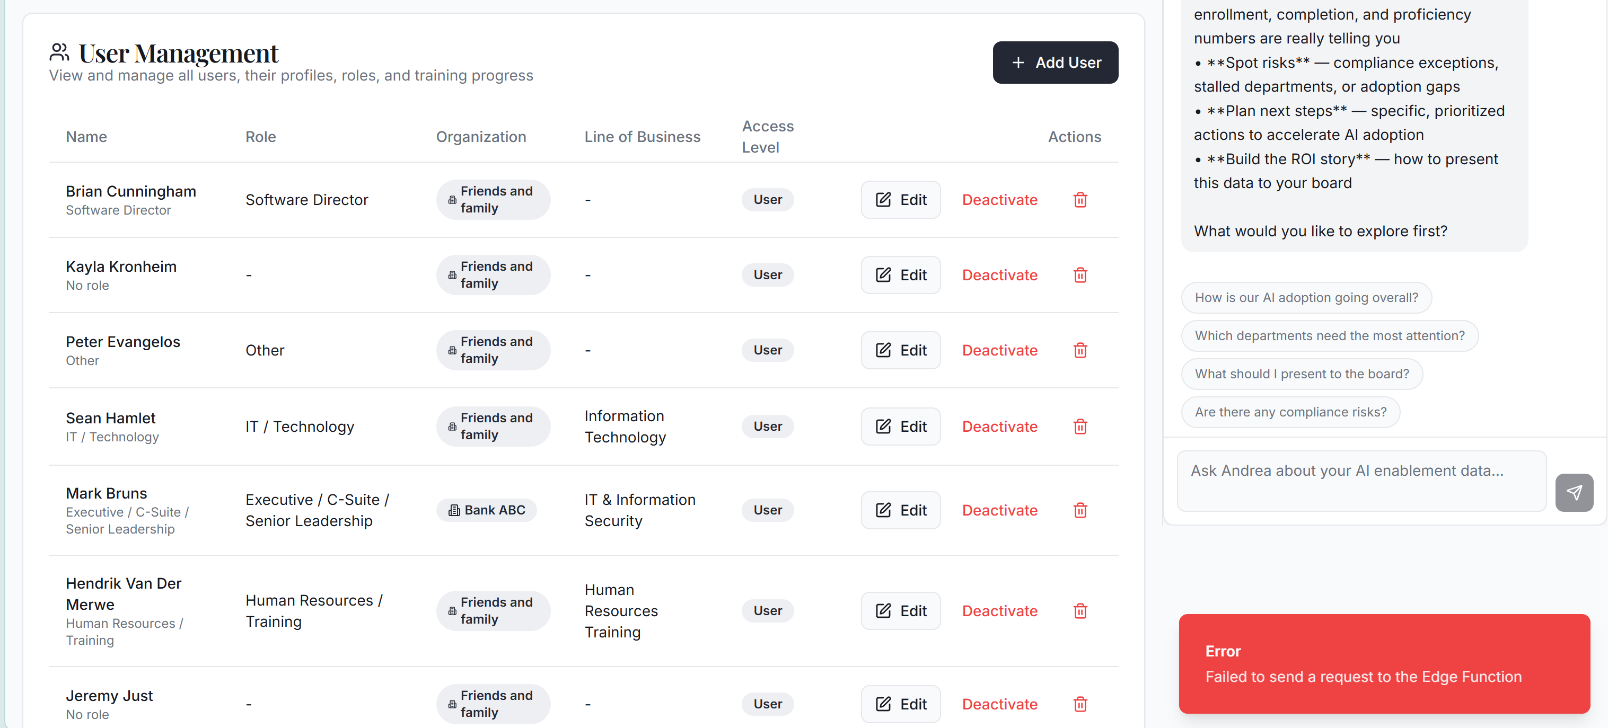

The margins are too small in the left pane.
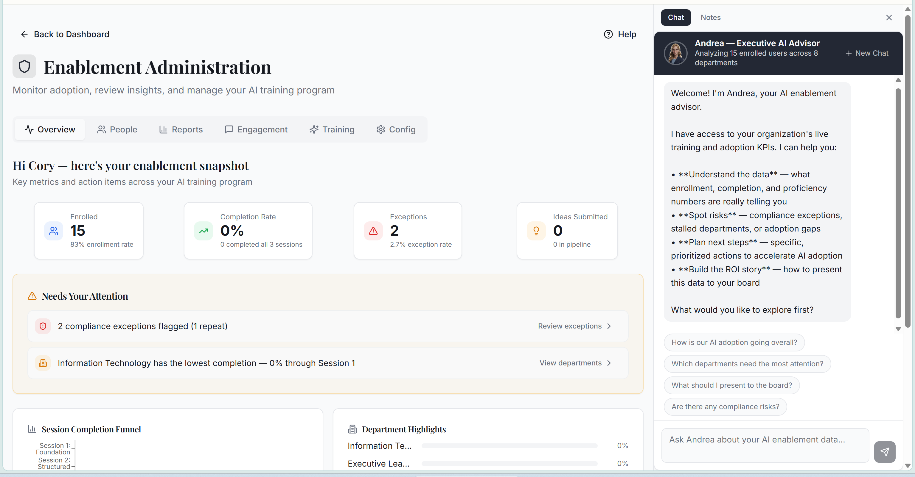
The ChatGPT model should be GPT 5.4.
The Gemini model should be Gemini 3.
As Admin, I should be able to change my organization to any of the organizations
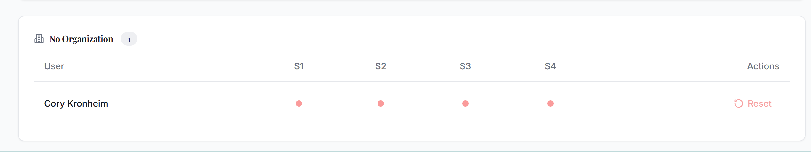

In the Sessions, the Modules pane should be removed. The modules should be viewable as a horizontal dropdown if you click on the session name. It should only expand until the next click (if you click on the module, and its unlocked, the user is taken to it. If the user clicks elsewhere, the horizontal module drop down collapses. For example, clicking on 1 Foundations would show horizontally all of the module titles.
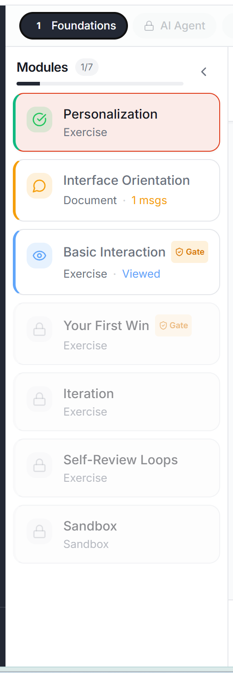

In the selections, this should be Green, so a user knows to click on it. And the title should be Click Here to Continue – See Examples. The button should very lightly radiate.
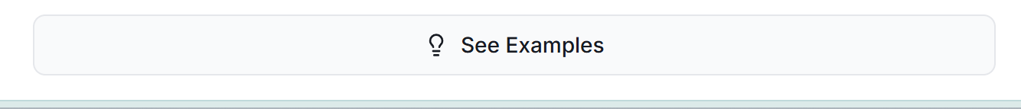
Same here – which appears on the screen after See Examples. This should be Green and the title should be Click Here to Continue – Start Practice. The button should very lightly radiate.

Andrea is too wordy here. Her responses should be no more than 40 words in each paragraph.

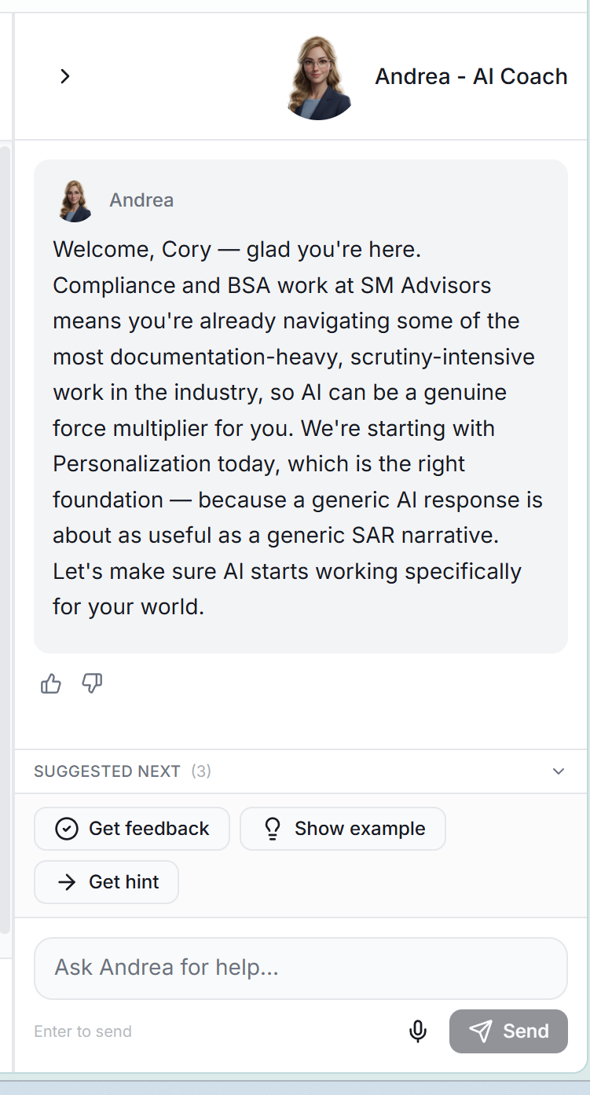

Remove the “”’s around the examples.
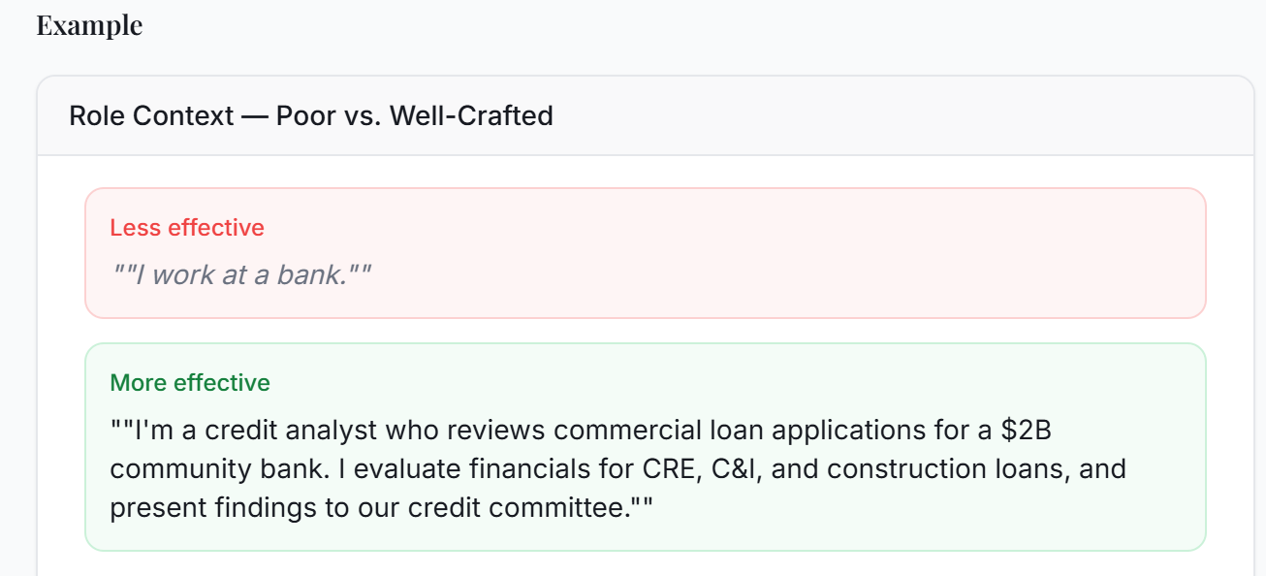

When I change screens, the module refreshes. It should remain on the specific screen when the user leaves to another window and then comes back.

This button in the modules should be Green and say Submit to Andrea and Save to Your SMILE profile
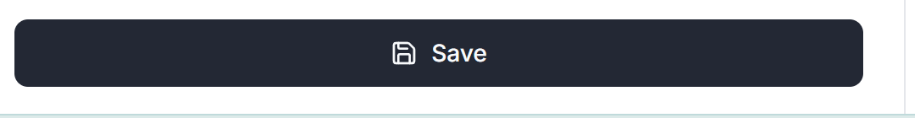

When the user clicks Start Practice, it isn’t clear that the user is getting their instructions on the Practice from Andrea. What would be better is if a pop up occurs to describe the instructions, then when the user clicks a Begin button (in green), the pop up collapses into the Andrea Chat and shows as a response from her in the chat – word for word.

